**PROJECT DESCRIPTION**

The project consists of a program made for a cooperative that has a series of ecologic orchards, the program must be able to permit the different kind of users to log in on the system and perform its predetermined function.

Team members:

Tadeo Gutierrez - coordinator

Sebastian Navarro - sub-coordinator

Mateo Cruz - member1

Diego Sánchez - member2

**SWOT ANALYSIS**

**What is SWOT analysis?**

The SWOT analysis is a diagnostic that is made by analyzing capacities, abilities and the positioning of your company. If we had to locate it in a timeline, SWOT analysis is the “picture” of the current situation of the enterprise.

A SWOT analysis is made to detect and take advantage of the OPPORTUNITIES that your business has in a specific moment, eluding THREATS, by a good use of your STRENGTHS and neutralization of your WEAKNESSES.

The SWOT analysis has two levels of analysis, an intern one and an external one. The things observed inwards are qualities and weak spots that your company has currently and affect the success possibilities of your strategy. What’s observed outwards is the environment, what can happen in that context. You must consider that you don’t have influence upon this last data, they must be taken only as a reference to understand the frame in wich your company works.

**SWOT characteristics**

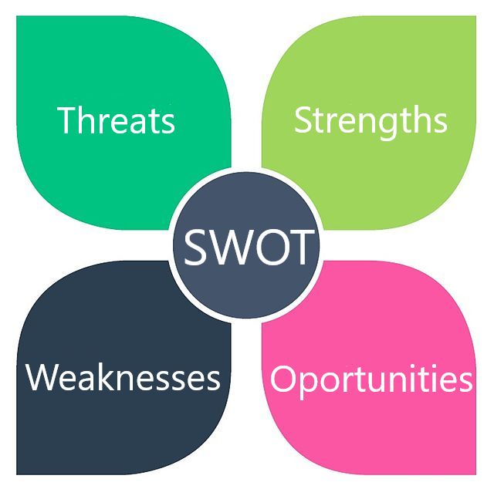

**Internal level:**

**Strengths:** Resources and special capacities of the

organization that put it in an advantageous position, they

are also positive aspects of the organization.

**Weaknesses:** they are negative aspects of the

organization and factors that provoke a non-favorable

position against the competition.

**External level:**

**Opportunities:** Events from the environment that can

positively affect the performance of the organization and

can create competitive advantages if they are exploited.

**Threats:** Events from the environment that can negatively affect the performance of the organization and can attack against its permanency.

**Sources:**

**Santander bank:**

[**https://www.santander.com.ar/banco/online/pymes-advance/formacion-empresarial/pildoras-de-conocimiento/marketing/foda-saber-donde-estoy**](https://www.santander.com.ar/banco/online/pymes-advance/formacion-empresarial/pildoras-de-conocimiento/marketing/foda-saber-donde-estoy)

**Blueprint by Gabriel Barboza**

[**https://www.dropbox.com/s/vc4olmhr5bs5zi3/Anteproyecto.pdf?dl=0**](https://www.dropbox.com/s/vc4olmhr5bs5zi3/Anteproyecto.pdf?dl=0)



**SWOT analysis for Daysware:**

|  |  |
| --- | --- |
| **Strengths:**   * Good job distribution in the different sectors of informatics. * Great teamwork efficiency | **Weaknesses:**   * Little benefit from a demographic point of view * Lack of resources for computer facilities |
| **Opportunities:**   * Good relationship with other companies in the category * Large working market | **Threats:**   * “zero day” type attacks * Sabotage from other similar companies * Lack of basic services in the localization of the company |

**EXECUTIVE SUMMARY**